Handy Hints From Other

Cool Schools Coordinators

Celebrating Successes of Peer Mediation
- Minor disputes being reduced and solved in the playground
- Children’s enthusiasm with the process
- Leadership opportunities for students
- Enhances children’s problem-solving and communication skills, that stay for life and parents appreciate
- Great to have a common vocabulary
- Children love learning about response options to conflict (the 5 animals)
- Great feedback on Facebook posts
- Improves students confidence
- Fosters positive relationships between junior and senior students
- Gives students the chance to take responsibility for peer behaviour in the playground
- Changes the whole school culture
- Calmer environment at school
- Children get involved with event organising
- Frees up duty teachers because they don’t have to deal with minor conflict - the mediators do this

Tackling Challenges
- Finding time to train student peer mediators
- Keeping teachers on the timeline.
- Keeping momentum up
- Year 8 students lose interest quickly
- Peer mediators trying to force a mediation that wasn’t wanted
- Lack of support from teachers, lack of knowledge, staff who are unfamiliar with programme
- Schools don’t take it seriously – lack of support
- Shift the culture (gang). Effects on community.
- Checking up on mediators
- How to train the mediators

- Finding time to familiarise with resources (CSPrimary Manual and Coordinator’s Kit on USB stick)
- Time to do the programme properly
- Keeping the mediators motivated
- Reminding peer mediators about their duties
- Busyness of seniors
- Older children not listening to younger mediators
- Seniors looking for problems/ being a policeman type of mediator and therefore into rule enforcement/ power over others
- Children being afraid of mediators and therefore do not use the mediation service

Sharing possible Solutions

Finding time to train students
- Whole day workshop for mediators (Emma) – that means one day leave for teacher
- Important: initial training and weekly meetings – for initial training, Christina was released for two day training with School PM (Peer Mediators)
- Take 30 mins of 50 min lunchtime for training/meeting once a week (Jamie)
- Christina was released to have PM meeting during class-time once a week, 30 mins before lunch on a Friday morning
- Christina: Ask for your needs to be met!
- What do you need? Pay rise? Staff meetings? Release time? Another teacher to help coordinate the mediators? A Cool Schools budget each year? Etc.

Schools and teachers don’t take the programme seriously
- Christina: brief staff on important issues, involve them in handling difficult situations
- Class mediators should have support of class teachers – classroom mediator’s are the teachers responsibility (train staff!); School PMs are the Coordinator’s responsibility
- Be present; assembly presentation, introduce your PMs on notice board in foyer with profile pictures of each – let them feel good about themselves!
- Be flexible to change PM’s duty rosters for different terms
- It’s part of the PMs responsibility to keep track of their timetable
- Wayne: let PMs present themselves and skills such as ‘The 5 Animals’ in different classes

Shift the Culture
- Whole School Approach!
- When classroom teachers teach the classroom skills, PMs don’t have to start from scratch when they begin their training
- Keep the parents involved
- Emma: Letter to parents - your child has been accepted as peer mediator etc, this is what it’s all about
- Parents Cool Schools Information evening: it can be challenging getting the parents into the school
- Christina: Combine parents information with a Cool School Revisit from a Peace Foundation facilitator – let the students plan the evening, do a presentation, do The 5 Animal exercise. Ask Parents what the role of a mediator is, combine with other information about the programme and conclude with kai

What to do in a training
- Emma: Mix of problems and solutions, if time recap new skills
- Jamie: play team building games
- Christina: rapport building, role play the mediation process in groups of four, then critique the role play as a larger group:
- “What went well in this mediation?”
- “What are some helpful suggestions for the next mediation?”
- End meeting with discussions, sharing, problem solving
- Report back to staff
- Craig: Integrate units from the Cool School Manual every year in classrooms (not use it once then lose it).
- Keeping relationships in tact - empowering students - common language with restorative practices.

How to keep the Peer Mediators motivated
- Christina: number-wise – have a smaller team and a regular roster – all PM’s should be out on the playground once a week not to get bored and to keep training
- Have a manager each week on duty to tick PMs off the list once they appear, keep track of gear, find the ones who are missing, step in if someone is away (admin)
- Divide playground into different zones for PMs on duty. Two in each zone.
- Let PMs apply for the job, have a contract/mediators agreement (keep them accountable; check if a PM needs support)
- Emma: Reward system, 3 levels
- Bronze, silver, gold – different criteria for each level which can be unique for each school (i.e. attending training, knowing the rules of peer mediation, etc.)
- In the 2nd year as PM, they can get involved with peace projects
- Emma: “In order to be ‘Peace Ambassador’ they need to leave a legacy at the school” (i.e. content on Website, booklet for juniors, running Youth Peace Week, actioning a Peace Garden and Friendship seat, running a programme within the school such as The Virtues Project, producing a Peace Mural, etc.)
- Train apprentice mediators
- Badges – training plus one term on duty → trained mediator uniform badge; work through criteria to gold level to get graduation badge
- Peace Ambassadors: Christina offers to come to the school to award these badges and certificates if in Auckland region
- Stickers – especially for juniors → you can talk about it in class and at home: “How did you make a mediator happy today?”
- Spotting good behaviour/positive behaviour/solving problems
- Emma bought bags for PMs with a board, stickers, stress ball, tissues - everything they need when they are on duty
- Christina: When the PMs get redundant that’s great! This can be a sign of a peaceful school where students from all levels are doing their own problem solving. Then the school peer mediators can get involved with their peace projects.

Create a “Profile” – when seniors don’t take PMs seriously
- Christina: show peers what the alternative to peer mediation would be – duty teacher to sort out your problems. Is that what you want?
- Peer Mediation: advantage: no teacher involvement, students keep control, mediation takes place, students supporting students to resolve conflict
- Emma: let PMs go around the classrooms, get known (Section 3 of Cool Schools Manual: Road Show)
- Junior classrooms: let PMs create a puppet show to demonstrate the mediation process, also perform this in a staff meeting
- Introduce PMs to juniors: relationship building activities
- Emma: PMs can prepare a talent show, Youth Peace Week, other projects to stay busy and present (also see 5.) → start a term beforehand
- Make it clear that everybody can be learner and teacher, not depending on the age
- Reward System gives status to PMs
- Classroom teachers need to do their bit, introduce advantages of PMs …
- Students working with students, no teacher involvement (student agency)
- Peer mediation is a voluntary, confidential process
- Choice between peers and teacher
- Christina: Look for PMs from different cultures, gender, sport and academic ability so that they represent the whole student body/school character
- Get inspired by Secondary Schools approaches
- Make it cool – i.e. go on a peer mediator camp (great for Year 7+8 students)
- In a whole school approach every duty teacher should be able to help out with a mediation when asked by the PM’s
- Make it clear that PM’s are
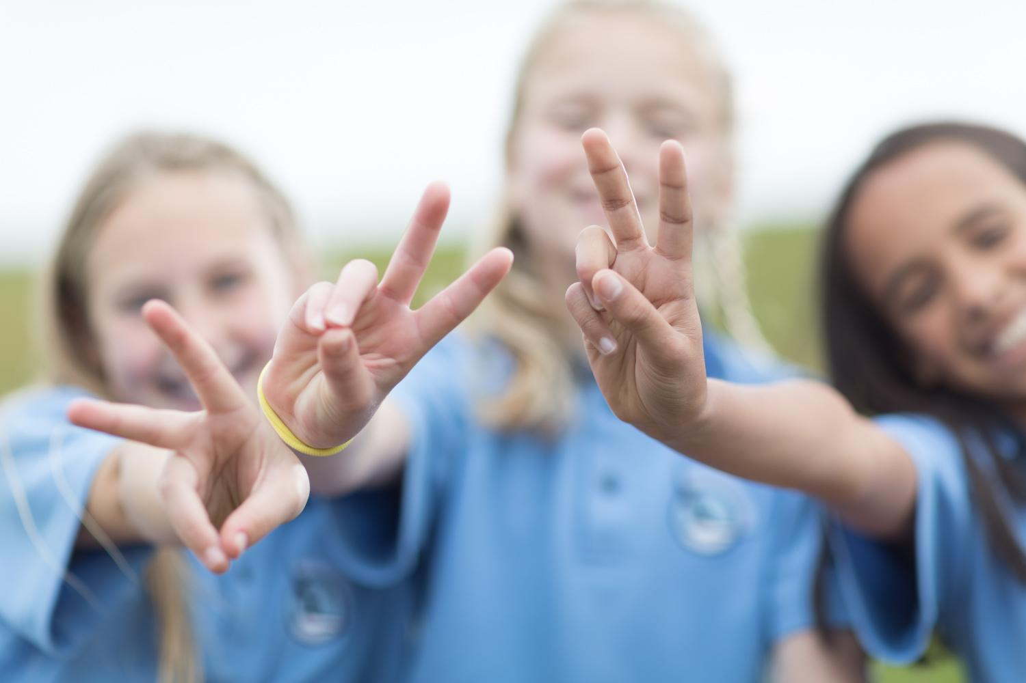
not mini-teachers

Other Ideas for Peer Mediators
- “Loneliness Eliminators” - seek out kids by themselves
- Peer mediators could plan their own lessons and go in to classes to teach these
- Organise event - Peace Week, talent quest etc…
- Peace Week - 4-8th August every year; plan early in the year
- Create Peace Garden - tie in with gardening club (Papakura Normal School)
- Friendship Seat – decorate with peace graffiti
- Often conflict-prone kids are good mediators when given the opportunity to learn skills. Don’t be afraid to give them an opportunity to be in the PM’s team
- Peace T-Shirt, create a film or video create a song
- Discuss with PMs: records of conflicts happening in the playground - is there a pattern of behaviour?
- Teacher involvement in selection process: Year five teachers/senior managers feed in to decision of who will be in the school team
- PM shared lunch each term as a ‘thank you’ for their service
- Visit the ‘frequent flyers’ and have them reflect
- Have a Cool Schools App on device with forms, to avoid paper trail
- Official acceptance letter → also termination letter? - signed by parents
- Cool Schools Teachers Only Day whole staff training. Cool Schools Revisit - 3hrs → 1hr Coordinator Meeting, 1.5 hrs with student PMs, 1.5hrs staff meeting after school
- Encourage discussion in class and it being okay → I disagree with you.../I agree with you…
- PMs to make posters to hang around school
- Refresher training from Peace Foundation for new staff - see website for details (www.peace.net.nz)
- Teachers need to promote the PMs more when they are on duty: "Have you seen the PMs about that problem?”

