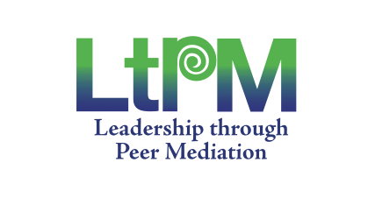
Certificate of Achievement

Presented to
_________________________________________________
for demonstrating awareness and understanding of
Peaceful Conflict Resolution and Peer Mediation Skills
held at:
date:
Programme Facilitator/s

LtPM Programme Coordinator

Principal

