Peace Ambassadors - Leaving a Legacy

by Christina Barruel – Head of Peace Education

Peer mediators from both primary and secondary schools can work towards becoming Peace Ambassadors at their school. What does this mean?

As a Peace Ambassador, you create, develop and work on projects that really make a difference on a school-wide level. Here are some examples of Peace Ambassador projects:

- Planning, organizing and promoting activities throughout the school for Youth Peace Week, Pink Shirt Day, International Day of Peace and other such annual events which have national and international significance.
- Creating a booklet or brochure on peer mediation for peers.
- Designing classroom posters on how to solve problems constructively.
- Producing a ‘Peace’ mural on an outside wall within the school grounds.
See below an example from Upper Harbour Primary School.
- Producing a peer mediation website link.
- Producing a peer mediation video with role-play examples of mediation in action for peers so they gain understanding of the process of mediation and the role of a mediator. Send the Peace Foundation a copy please!
- Producing a ‘Peace Garden’ in the school with a ‘Peace’ seat for students to use when they need ‘quiet time’ or time for reflection. Students can also meet new friends on the ‘Peace’ seat.
- Designing and creating a peer mediation App to support and improve the administration side of the role (advanced technical skills required).

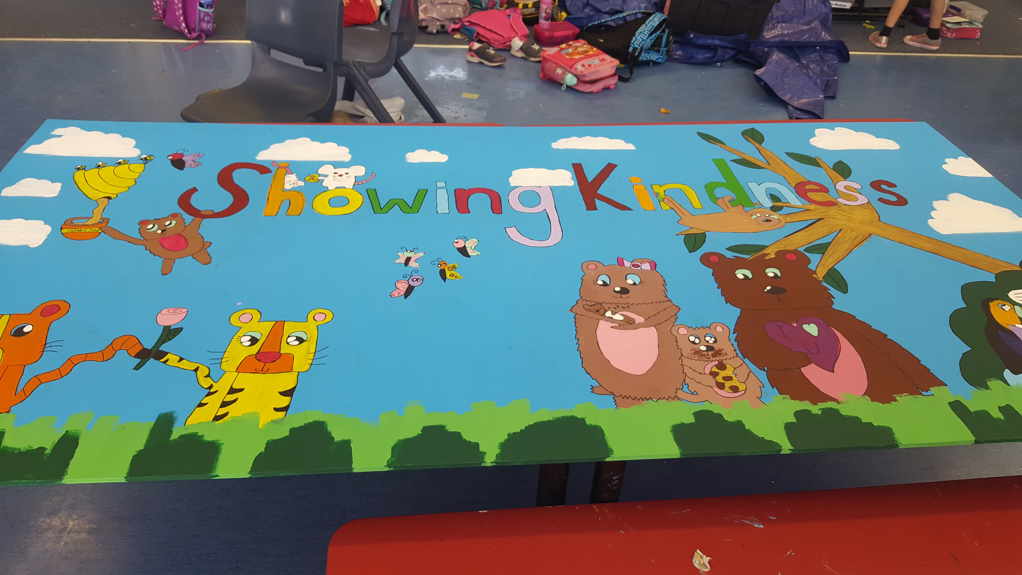
Students who make the extra effort showing initiative and determination to create a legacy at their school, will be presented a Peace Ambassador Award by the Peace Foundation. This will include a certificate and a badge. For more information on Peace Ambassadors or to present your student Peace Ambassador list, please email: christina@peacefoundation.org.nz

