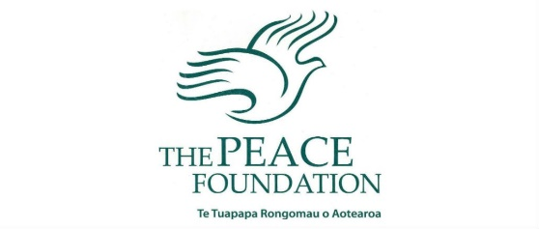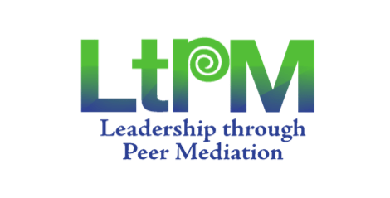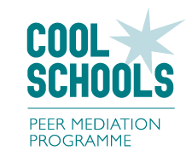

Dear Parents, Caregivers and Families,

We are proud to announce that ACTS Community School is a ***‘Cool School’.***

This year, we have partnered with **The Peace Foundation New Zealand** to implement two conflict resolution programmes in our school, **Leadership through Peer Mediation** in the High School and **Cool Schools Peer Mediation** in the Primary School. Through these programmes we aim to

* develop a whole school-wide approach to dealing with conflict,
* provide opportunities for students to demonstrate and apply positive behaviours.
* Empower students to find non-violent solutions to their problems.
* Grow our students to be servant leaders.

**Peer Mediation** is a positive way to resolve conflict that both our teachers and students have been trained in through fun, engaging and empowering lessons. Volunteer student **peer mediators** have done extra training to assist in helping their peers solve conflicts in the playground. The skills we have been learning are not just for within the school environment but we see it as part of ***equipping young people for life*** and ***raising a generation*** who will take what they have learned into their communities, their nation and beyond.

For more information and resources just ask your children! You can also visit  
 <https://www.peacefoundation.org.nz/> and <https://www.peacefoundation.org.nz/education/>

***Romans 14:19 So then, make it your top priority to live a life of peace with harmony in your relationships, eagerly seeking to strengthen and encourage one another***

Dear Parents, Caregivers and Families,

We are proud to announce that ACTS Community School is a ***‘Cool School’.***

This year, we have partnered with **The Peace Foundation New Zealand** to implement two conflict resolution programmes in our school, **Leadership through Peer Mediation** in the High School and **Cool Schools Peer Mediation** in the Primary School. Through these programmes we aim to

* develop a whole school-wide approach to dealing with conflict,
* provide opportunities for students to demonstrate and apply positive behaviours.
* Empower students to find non-violent solutions to their problems.
* Grow our students to be servant leaders.

**Peer Mediation** is a positive way to resolve conflict that both our teachers and students have been trained in through fun, engaging and empowering lessons. Volunteer student **peer mediators** have done extra training to assist in helping their peers solve conflicts in the playground. The skills we have been learning are not just for within the school environment but we see it as part of ***equipping young people for life*** and ***raising a generation*** who will take what they have learned into their communities, their nation and beyond.

For more information and resources just ask your children! You can also visit  
 <https://www.peacefoundation.org.nz/> and <https://www.peacefoundation.org.nz/education/>

***Romans 14:19 So then, make it your top priority to live a life of peace with harmony in your relationships, eagerly seeking to strengthen and encourage one another***