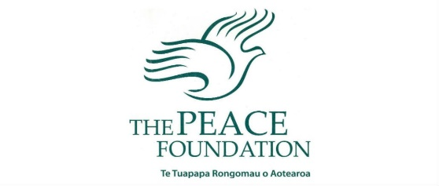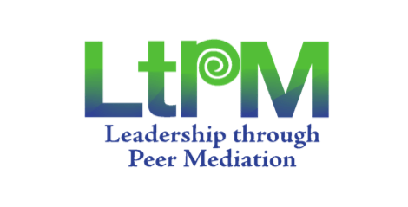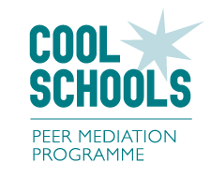

Dear Parents, Caregivers and Families,

We trust you have received the newsletter regarding our status as a Cool School.

Your child has been identified as having the potential to become a student Peer Mediator. They have completed the five hours training to be able to assist their peers in conflict resolution in the playground.

For Primary students this is called the Peer Mediation Programme and for the High School, the Leadership through Peer Mediation programme.

Both programmes provide students with pathways to develop their ability to lead and to do good in the school community. Peer mediators support their peers in conflict to reach peaceful agreements without teacher intervention. Students trained as peer mediators, can step up as leaders and role models. They can become “Ambassadors of Social Justice” or “Peace Ambassadors”, modelling and promoting the importance of kindness, fairness, empathy and respect for all.  
  
For the high school students, this service is something that can go on their CV and be recognised by their future tertiary or work environments.

For more information and resources just ask your children! You can also visit  
 <https://www.peacefoundation.org.nz/> and <https://www.peacefoundation.org.nz/education/>

***Romans 14:19 So then, make it your top priority to live a life of peace with harmony in your relationships, eagerly seeking to strengthen and encourage one another***

Dear Parents, Caregivers and Families,

We trust you have received the newsletter regarding our status as a Cool School.

Your child has been identified as having the potential to become a student Peer Mediator. They have completed the five hours training to be able to assist their peers in conflict resolution in the playground.

For Primary students this is called the Peer Mediation Programme and for the High School, the Leadership through Peer Mediation programme.

Both programmes provide students with pathways to develop their ability to lead and to do good in the school community. Peer mediators support their peers in conflict to reach peaceful agreements without teacher intervention. Students trained as peer mediators, can step up as leaders and role models. They can become “Ambassadors of Social Justice” or “Peace Ambassadors”, modelling and promoting the importance of kindness, fairness, empathy and respect for all.  
  
For the high school students, this service is something that can go on their CV and be recognised by their future tertiary or work environments.

For more information and resources just ask your children! You can also visit  
 <https://www.peacefoundation.org.nz/> and <https://www.peacefoundation.org.nz/education/>

***Romans 14:19 So then, make it your top priority to live a life of peace with harmony in your relationships, eagerly seeking to strengthen and encourage one another***

